Spring Transaction Management Support
Spring provides support for both programmatic and declarative transactions.
- Programmatic Transactions – With programmatic transactions , transaction management code like, commit when everything is successful or rolling back if anything goes wrong is clubbed with the business logic.
- Declarative Transactions-Declarative transactions separates transaction management code from business logic. Spring supports declarative transactions using transaction advice (using AOP).

Choosing declarative or programmatic transactions is convenience versus fine control. Programmatic approach provides a fine control on transaction boundaries, whereas declarative approach provides a great configurability using configuration files.

If our application is working with one data source only then we can manage the transactions using commit and rollback methods of transaction object, but to have a transaction between multiple data sources we would need to rely on transaction management provides by J2EE servers . Spring also supports distributed transactions

Transaction Manager :
Spring supports several transaction managers which delegate the transaction management responsibilities to platform specific implementations. Platform Transaction manager is the parent of all transaction manager implementations.
Some of the transaction managers are-
- DataSource Transaction manager - We can use DataSourceTransactionManager for simple JDBC persistence mechanism.
<bean id=”transactionManager”
class=”org.springframework.jdbc.datasource.DataSourceTransactionManager>
<property name=”dataSource” ref= “datasource” />
</bean>

- Hibernate Transaction manager – Hibernate transaction manager should be used when our application is using Hibernate.
<bean id=”transactionManager”
class=”org.springframework.orm.hibernate3.HibernateTransactionManager>
<property name=”sessionFactory” ref= “sessionFactory” />
</bean>

- Jdo Transaction manager –Use below configuration to use Java data object transaction manager .
<bean id=”transactionManager”
class=”org.springframework.orm.jdo.JdoTransactionManager>
<property name=”persistanceManagerFactory” ref= “persistanceManagerFactory” />
</bean>

- Jta Transaction manager – If our transaction is across multiple data sources than we need to use Java Transactions API transactions . Internally JTA implementation handles transaction responsibility.
Use below configuration to configure JTA transaction manager.

<bean id=”transactionManager”
class=”org.springframework.transaction.jta.JtaTransactionManager>
<property name=”transactonManagerName” ref= “java:/TransactionManager” />
</bean>

Programmatic Transaction Management
Spring provides platform independent Transaction manager API with the help of an abstract transaction management unit known as PlatformTransactionManager interface under org. springframework. transaction package.

This interface defines below methods:
- getTransaction(TransactionDefinition)- This method returns a transaction (either a active transaction or create a new one)
- void commit(TransactionStatus)- This method commits the transaction based on the status.
- void rollback(TransactionStatus)- This method rollbacks the transaction based on status.

TransactionStatus interface defines several methods to get the status of transaction and controls the transaction execution as well.

private PlatformTransactionManager transactionManager;

public void setTransactionManager( PlatformTransactionManager transactionManager){
this.transactionManager = transactionManager;
}

public void buyProduct(String username , int productId){
TransactionDefinition def = new DefaultTransactionDefinition();
TransactionStatus status = transactionManager.getTransaction(def);
try
{
int price = jdbcTemplate.queryForInt
( "SELECT PRICE FROM PRODUCTS WHERE Id = ?",new Object[] { new Integer(productId) });
jdbcTemplate.update("UPDATE PRODUCTS SET STOCK =
STOCK - 1 WHERE ID = ?", new Object[] { new Integer(productId) });
jdbcTemplate.update( "UPDATE ACCOUNT SET AMOUNT =
AMOUNT - ? WHERE USERNAME = ?", new Object[] { price, username });
transactionManager.commit(status);
}
catch (DataAccessException e){
transactionManager.rollback(status);
throw e;
}
}
beans.xml:
<beans >
<bean id="dataSource"
class="org.springframework.jdbc.datasource.DriverManagerDataSource">
<property name="driverClassName" value="com.mysql.jdbc.Driver"/>
<property name="url" value="jdbc:mysql://localhost:3306/SpringJDBC"/>
<property name="username" value="root"/>
<property name="password" value="password"/>
</bean>

<bean id="buyProduct" class="jdbc.BuyProduct">
<property name="dataSource" ref="dataSource" />
<property name="transactionManager" ref="transactionManager" />
</bean>

<bean id="transactionManager"
class="org.springframework.jdbc.datasource.DataSourceTransactionManager">
<property name="dataSource" ref="dataSource" />
</bean>

</beans>

Declarative Transaction Management:
As we saw in programmatic approach has a tight coupling on the transaction code with business logic. In Declarative transactions, we can separate transaction management code from business logic.
Spring supports declarative transactions using

- Transaction Advices (using Aspect Oriented Programming) - In this approach we need to-
- declare a transaction advice via the <tx:advice> element defined in the tx namespace.
For example

<tx:advice id="txAdvice"
transaction-manager="transactionManager">
<tx:attributes>
<tx:method name="buy*" propagation="REQUIRED"/>
<tx:method name="*" propagation="SUPPORTS" />
</tx:attributes>
</tx:advice>
Transaction advice defines <tx:attributes> element which can have several <tx:method> tags to define several properties. In above example, any method whose name starts with “buy” are required or a part of the transaction, but all other methods will execute in current transaction but will not create a new if the transaction does not exist.

- Now we need to associate transaction advice (<tx:advice>) with a pointcut using <aop:config>

<aop:config>
<aop:advisor advice-ref="txAdvice"
pointcut =" execution(* jdbc.BuyProduct.buyProduct(..))"/>
</aop:config>

Transaction Advice Example:

<beans>
<bean id="dataSource"
class="org.springframework.jdbc.datasource.DriverManagerDataSource">
<property name="driverClassName" value="com.mysql.jdbc.Driver" />
<property name="url" value="jdbc:mysql://localhost:3306/SpringJDBC" />
<property name="username" value="root" />
<property name="password" value="password" />
</bean>

<bean id="purchaseProduct" class="jdbc.PurchaseProduct">
<property name="dataSource" ref="dataSource" />
</bean>

<bean id="transactionManager"
class="org.springframework.jdbc.datasource.DataSourceTransactionManager">
<property name="dataSource" ref="dataSource" />
</bean>

<tx:advice id="txAdvice" transaction-manager="transactionManager">
<tx:attributes>
<tx:method name="buy*" propagation="REQUIRED" />
<tx:method name="*" propagation="SUPPORTS" />
</tx:attributes>
</tx:advice>

<aop:config>
<aop:advisor advice-ref="txAdvice"
pointcut=" execution(* jdbc.PurchaseProduct.buyProduct(..))" />
</aop:config>
</beans>

@Transactional Annotation : Along with the declarative approach with pointcut , advisors configuration in beans configuration file ,

Spring allows another way of declarative transaction management using @Transactional annotation on the method which requires transaction and enabling <tx:annotation-driven> element in the beans configuration file. This approach requires JDK1.5 onwards.

We can put the annotation on definitions of interfaces, classes, or directly on methods. They override each other according to the priority order; from lowest to highest we have: Interface, superclass, class, interface method, superclass method, and class method.

Spring applies the class-level annotation to all public methods of this class that we did not annotate with @Transactional.
However, if we put the annotation on a private or protected method, Spring will ignore it without an error.

@Transactional
public interface TransferService {
void transfer(String user1, String user2, double val);
}

Usually, it is not recommended to set the @Transactional on the interface. However, it is acceptable for cases like @Repository with Spring Data.
We can put the annotation on a class definition to override the transaction setting of the interface/superclass:

@Service
@Transactional
public class TransferServiceImpl implements TransferService {
@Override
public void transfer(String user1, String user2, double val) {
// ...
}
}
Now let's override it by setting the annotation directly on the method:

@Transactional
public void transfer(String user1, String user2, double val) {
// ...
}

@Transactional Annotation Example:
<beans >

<tx:annotation-driven transaction-manager="transactionManager"/>

<bean id="transactionManager"
class="org.springframework.jdbc.datasource.DataSourceTransactionManager">
<property name="dataSource" ref="dataSource" />
</bean>
</beans>

@Transactional
public void buyProduct(String username , int productId){…}

Transaction propagation Behavior :Propagation defines our business logic’s transaction boundary. Spring manages to start and pause a transaction according to our propagation setting.

Spring calls TransactionManager::getTransaction to get or create a transaction according to the propagation. It supports some of the propagations for all types of TransactionManager, but there are a few of them that only supported by specific implementations of TransactionManager.

Transaction Propagation behavior can be specified in <tx:method> element.

Below are some of the most commonly used propagation modes.

- REQUIRED Propagation : REQUIRED is the default propagation. Spring checks if there is an active transaction, then it creates a new one if nothing existed. Otherwise, the business logic appends to the currently active transaction.

- current method must run in an existing transaction and if there are no existing transactions the start a new transaction and run within it.

@Transactional(propagation = Propagation.REQUIRED)
public void requiredExample(String user) { // ... }

@Transactional
public void requiredExample(String user) { // ... }
Let's see the pseudo-code of how transaction creation works for REQUIRED propagation:

if (isExistingTransaction()) {
if (isValidateExistingTransaction()) {
validateExisitingAndThrowExceptionIfNotValid();
}
return existing;
}
return createNewTransaction();
- REQUIRES_NEW Propagation :When the propagation is REQUIRES_NEW, Spring suspends the current transaction if it exists and then creates a new one:

@Transactional(propagation = Propagation.REQUIRES_NEW)
public void requiresNewExample(String user) {
// ...
}
Similar to NOT_SUPPORTED, we need the JTATransactionManager for actual transaction suspension.

- SUPPORTS Propagation :For SUPPORTS, Spring first checks if an active transaction exists. If a transaction exists, then the existing transaction will be used. If there isn't a transaction, it is executed non-transactional.

Current method can run in existing transaction if exists else it is not necessary to run within a transaction.

@Transactional(propagation = Propagation.SUPPORTS)

Let's see the transaction creation's pseudo-code for SUPPORTS:

if (isExistingTransaction()) {
if (isValidateExistingTransaction()) {
validateExisitingAndThrowExceptionIfNotValid();
}
return existing;
}
return emptyTransaction;

- NOT_SUPPORTED Propagation : Spring at first suspends the current transaction if it exists, then the business logic is executed without a transaction.

@Transactional(propagation = Propagation.NOT_SUPPORTED)
public void notSupportedExample(String user) {
// ...
}

- MANDATORY Propagation :When the propagation is MANDATORY, if there is an active transaction, then it will be used. If there isn't an active transaction, then Spring throws an exception
- The current method must run within a transaction. If there’s no existing transaction in progress, an exception will be thrown.

if (isExistingTransaction()) {
if (isValidateExistingTransaction()) {
validateExisitingAndThrowExceptionIfNotValid();
} return existing;
}
throw IllegalTransactionStateException;

- NEVER Propagation :For transactional logic with NEVER propagation, Spring throws an exception if there's an active transaction:

@Transactional(propagation = Propagation.NEVER)
public void neverExample(String user) {
// ...
}
- Let's see the pseudo-code of how transaction creation works for NEVER propagation:

if (isExistingTransaction()) {
throw IllegalTransactionStateException;
}
return emptyTransaction;

- NESTED Propagation :For NESTED propagation, Spring checks if a transaction exists, then if yes, it marks a savepoint. This means if our business logic execution throws an exception, then transaction rollbacks to this savepoint. If there's no active transaction, it works like REQUIRED.

DataSourceTransactionManager supports this propagation out-of-the-box. Also, some implementations of JTATransactionManager may support this.

JpaTransactionManager supports NESTED only for JDBC connections. However, if we set nestedTransactionAllowed flag to true, it also works for JDBC access code in JPA transactions if our JDBC driver supports savepoints.

Finally, let's set the propagation to NESTED:

@Transactional(propagation = Propagation.NESTED)
public void nestedExample(String user) {
// ...
}

Isolation Levels : When multiple transactions in the application are operating concurrently on the same data can lead to below problems.
- Dirty Read – If there are two transactions running concurrently and one thread has read the data which is being updated but not yet committed by another transaction and instead of committing, it rolls back the changes.
  - read the uncommitted change of a concurrent transaction
- Non repeatable read- This problem occurs when a transaction gets the different data for the same query when executed multiple times. This usually happens if another transaction is committing the data simultaneously.
  - get different value on re-read of a row if a concurrent transaction updates the same row and commits
- Phantom Read- this problem occurs when a transaction is inserting new data while another transaction is reading the data. In this scenario reading transaction will find additional data which was not there earlier.
  - get different rows after re-execution of a range query if another transaction adds or removes some rows in the range and commits

We can set the isolation level of a transaction by @Transactional::isolation. It has these five enumerations in Spring: DEFAULT, READ_UNCOMMITTED, READ_COMMITTED, REPEATABLE_READ, SERIALIZABLE.

In ideal scenario, transactions should be completely isolated from each other
Following are the most commonly used Isolation levels and are supported by Spring.
- DEFAULT – This isolation level uses the default isolation level of the underlying database.
The default isolation level is DEFAULT. So when Spring creates a new transaction, the isolation level will be the default isolation of our RDBMS. Therefore, we should be careful if we change the database.
We should also consider cases when we call a chain of methods with different isolation. In the normal flow, the isolation only applies when a new transaction created. Thus if for any reason we don't want to allow a method to execute in different isolation, we have to set TransactionManager::setValidateExistingTransaction to true.

- READ UNCOMMITTED – This isolation level supports transactions to read uncommitted data by other transactions as well. With this isolation, there are chances of dirty read, nonrepeatable read, and phantom read.
READ_UNCOMMITTED is the lowest isolation level and allows for most concurrent access.
As a result, it suffers from all three mentioned concurrency side effects. So a transaction with this isolation reads uncommitted data of other concurrent transactions. Also, both non-repeatable and phantom reads can happen. Thus we can get a different result on re-read of a row or re-execution of a range query.
We can set the isolation level for a method or class:
Postgres does not support READ_UNCOMMITTED isolation and falls back to READ_COMMITED instead. Also, Oracle does not support and allow READ_UNCOMMITTED.

- READ COMMITTED - This isolation level supports transactions to read only data committed by other transactions as well. There are chances of nonrepeatable read and phantom read.
The second level of isolation, READ_COMMITTED, prevents dirty reads.
The rest of the concurrency side effects still could happen. So uncommitted changes in concurrent transactions have no impact on us, but if a transaction commits its changes, our result could change by re-querying.
READ_COMMITTED is the default level with Postgres, SQL Server, and Oracle.

- REPEATABLE_READ Isolation :The third level of isolation, REPEATABLE_READ, prevents dirty, and non-repeatable reads. So we are not affected by uncommitted changes in concurrent transactions.
Also, when we re-query for a row, we don't get a different result. But in the re-execution of range-queries, we may get newly added or removed rows.
Moreover, it is the lowest required level to prevent the lost update. The lost update occurs when two or more concurrent transactions read and update the same row. REPEATABLE_READ does not allow simultaneous access to a row at all. Hence the lost update can't happen.

REPEATABLE_READ is the default level in Mysql. Oracle does not support REPEATABLE_READ.

- SERIALIZABLE Isolation :SERIALIZABLE is the highest level of isolation. It prevents all mentioned concurrency side effects but can lead to the lowest concurrent access rate because it executes concurrent calls sequentially.
  - In other words, concurrent execution of a group of serializable transactions has the same result as executing them in serial.

Transactions : Basically, there are two distinct ways to configure Transactions, annotations and AOP, each with their own advantages.

Configure Transactions :Spring 3.1 introduces the @EnableTransactionManagement annotation that we can use in a @Configuration class to enable transactional support:

@Configuration
@EnableTransactionManagement
public class PersistenceJPAConfig{

@Bean
public LocalContainerEntityManagerFactoryBean entityManagerFactoryBean(){
//...
}
@Bean
public PlatformTransactionManager transactionManager(){
JpaTransactionManager transactionManager = new JpaTransactionManager();
transactionManager.setEntityManagerFactory(entityManagerFactoryBean().getObject() );
return transactionManager;
}}

However, if we're using a Spring Boot project and have a spring-data-* or spring-tx dependencies on the classpath, then transaction management will be enabled by default.

Configure Transactions With XML : For versions before 3.1, or if Java is not an option, here is the XML configuration using annotation-driven and the namespace support:

<bean id="txManager" class="org.springframework.orm.jpa.JpaTransactionManager">
<property name="entityManagerFactory" ref="myEmf" />
</bean>
<tx:annotation-driven transaction-manager="txManager" />

The @Transactional Annotation : With transactions configured, we can now annotate a bean with @Transactional either at the class or method level.

@Service
@Transactional
public class FooService {
//...
}

The annotation supports further configuration as well:
- the Propagation Type of the transaction
- the Isolation Level of the transaction
- a Timeout for the operation wrapped by the transaction
- a readOnly flag – a hint for the persistence provider that the transaction should be read only
- the Rollback rules for the transaction

Note that by default, rollback happens for runtime, unchecked exceptions only. The checked exception does not trigger a rollback of the transaction. We can, of course, configure this behavior with the rollbackFor and noRollbackFor annotation parameters.

Spring Transaction Management interview questions :

Have you worked on transaction management in your project : YES. I have worked on application level transactions

What is a transaction? : Transaction is a logical unit of work which either must be executed completely or must be rolled back completely. A database transaction is a sequence of actions that are treated as a single unit of work. These actions should either complete entirely or take no effect at all. Transaction management is an important part of RDBMS-oriented enterprise application to ensure data integrity and consistency.

Could you give me an example of a transaction? : Sure. The most common example of transaction is “Fund Transfer”.If we are transferring money from our account to someone else’s, then debit from our account and credit of other person’s account, BOTH must happen as part of one transaction.If not, there will be a mismatch in the account books and worst possible user experience.Either, both tasks should get completed or none.

What are different characteristics of a transaction? :Note: Remember the acronym ACID.
- Atomicity – Either everything happens or none.A transaction should be treated as a single unit of operation, which means either the entire sequence of operations is successful or unsuccessful.
- Consistency – All the application state changes should be exactly same as what is desired following all the rules and constraints. This represents the consistency of the referential integrity of the database, unique primary keys in tables, etc.
- Isolation – Within a transaction, different tasks can execute concurrently or in parallel, but to others, they are visible as a single unit.There may be many transaction processing with the same data set at the same time. Each transaction should be isolated from others to prevent data corruption.
- Durable – Once application changes are done in the database, it should survive any crashes or failure. Once a transaction has completed, the results of this transaction have to be made permanent and cannot be erased from the database due to system failure.
A real RDBMS database system will guarantee all four properties for each transaction. The simplistic view of a transaction issued to the database using SQL is as follows −
- Begin the transaction using begin transaction command.
- Perform various deleted, update or insert operations using SQL queries.
- If all the operation are successful then perform commit otherwise rollback all the operations.

Spring framework provides an abstract layer on top of different underlying transaction management APIs. Spring's transaction support aims to provide an alternative to EJB transactions by adding transaction capabilities to POJOs. Spring supports both programmatic and declarative transaction management. EJBs require an application server, but Spring transaction management can be implemented without the need of an application server.

Programmatic vs. Declarative :Spring supports two types of transaction management −
Programmatic transaction management − This means that you have to manage the transaction with the help of programming. That gives you extreme flexibility, but it is difficult to maintain.
Declarative transaction management − This means you separate transaction management from the business code. You only use annotations or XML-based configuration to manage the transactions.
Declarative transaction management is preferable over programmatic transaction management though it is less flexible than programmatic transaction management, which allows you to control transactions through your code. But as a kind of crosscutting concern, declarative transaction management can be modularized with the AOP approach. Spring supports declarative transaction management through the Spring AOP framework.

What are different components of Spring transaction management?
- First thing to know is PlatformTransactionManager
- TransactionDefinition is other which defines:
- Propagation method
- Time-out
- Read-only
- TransactionException

What are different isolation levels in Spring transaction?
- DEFAULT
- READ_COMMITTED
- READ_UNCOMMITTED
- REPEATABLE_READ
- SERIALIZABLE

What are different transaction propagation levels?
- PROPAGATION_MANDATORY: If current transaction exists, supports it otherwise throws exception.
- PROPAGATION_NESTED: If current transaction exists, executes within that.
- PROPAGATION_NEVER: Throws exception if current transaction exists.
- PROPAGATION_NOT_SUPPORTED: Does not support transaction whether it exists or not.
- PROPAGATION_REQUIRED: Supports transaction, if current transaction doesn’t exists it creates a new one.
- PROPAGATION_REQUIRED_NEW: Supports transaction. Always creates a new transaction even if there is already a current transaction in existence.
- PROPAGATION_SUPPORTS: If transaction exists, supports it. If not, doesn’t becomes part of the transaction.

What is the difference between different Spring transaction isolation levels?
Isolation levels differs in terms of: Dirty Read, Phantom Read and non-repeatable Read.
Isolation Level | Dirty Read? | Phantom Read? | Non-Repeatable Read?
DEFAULT | Same as datasource | Same as datasource | Same as datasource
READ_COMMITTED | No | Might | Might
READ_UNCOMMITTED | Might | Might | Might
REPEATABLE_READ | No | Might | No
SERIALIZABLE | No | No | No

transaction management : An important aspect of transaction management is defining the right transaction boundary, when should a transaction start, when should it end, when data should be committed in DB and when it should be rolled back (in the case of exception).
The most important aspect for developers is to understand how to implement transaction management in an application, in the best way. So now let's explore different ways.

Ways of Managing Transactions : A transaction can be managed in the following ways:

1. Programmatically manage by writing custom code
This is the legacy way of managing transaction.
EntityManagerFactory factory = Persistence.createEntityManagerFactory("PERSISTENCE_UNIT_NAME");
EntityManager entityManager = entityManagerFactory.createEntityManager();
Transaction transaction = entityManager.getTransaction()
try {
transaction.begin();
someBusinessCode();
transaction.commit();
} catch(Exception ex) {
transaction.rollback();
throw ex;
}
Pros: The scope of the transaction is very clear in the code.
Cons: It's repetitive and error-prone. Any error can have a very high impact.
A lot of boilerplate needs to be written and if you want to call another method from this method then again you need to manage it in the code.

2. Use Spring to manage the transaction
Spring supports two types of transaction management:
- Programmatic transaction management: This means that you have to manage the transaction with the help of programming. That gives you extreme flexibility, but it is difficult to maintain.
- Declarative transaction management: This means you separate transaction management from the business code. You only use annotations or XML-based configuration to manage the transactions. Declarative transactions are highly recommended.
Now, let us discuss each approach in detail.
2.1 Programmatic transaction management: The Spring Framework provides two means of programmatic transaction management.
a. Using the TransactionTemplate (Recommended by Spring Team):
Let's see how to implement this type with the help of below code :
Context XML file:
<!-- Initialization for data source -->
<bean id="dataSource" class="org.springframework.jdbc.datasource.DriverManagerDataSource"> <property name="driverClassName" value="com.mysql.jdbc.Driver"/>
<property name="url" value="jdbc:mysql://localhost:3306/TEST"/>
<property name="username" value="root"/>
<property name="password" value="password"/>
</bean>

<!-- Initialization for TransactionManager -->
<bean id="transactionManager" class="org.springframework.jdbc.datasource.DataSourceTransactionManager">
<property name="dataSource" ref="dataSource" />
</bean>

<!-- Definition for ServiceImpl bean -->
<bean id="serviceImpl" class="com.service.ServiceImpl">
<constructor-arg ref="transactionManager"/>
</bean>

Service Class:
public class ServiceImpl implements Service{
private final TransactionTemplate transactionTemplate;

// use constructor-injection to supply the PlatformTransactionManager
public ServiceImpl(PlatformTransactionManager transactionManager) {
this.transactionTemplate = new TransactionTemplate(transactionManager);
}

// the transaction settings can be set here explicitly if so desired hence better control
//This can also be done in xml file
this.transactionTemplate.setIsolationLevel(TransactionDefinition.ISOLATION_READ_UNCOMMITTED); this.transactionTemplate.setTimeout(30); // 30 seconds

// and so forth...

public Object someServiceMethod()
{
return transactionTemplate.execute(new TransactionCallback()
{
// the code in this method executes in a transactional context
public Object doInTransaction(TransactionStatus status)
{
updateOperation1();
return resultOfUpdateOperation2();
}
});
}}
If there is no return value, use the convenient TransactionCallbackWithoutResult class with an anonymous class
b. Using a PlatformTransactionManager implementation directly:
Let's see this option again with the help of code.
<!-- Initialization for data source -->
<bean id="dataSource" class="org.springframework.jdbc.datasource.DriverManagerDataSource">
<property name="driverClassName" value="com.mysql.jdbc.Driver"/>
<property name="url" value="jdbc:mysql://localhost:3306/TEST"/>
<property name="username" value="root"/>
<property name="password" value="password"/>
</bean>
<!-- Initialization for TransactionManager -->
<bean id="transactionManager" class="org.springframework.jdbc.datasource.DataSourceTransactionManager">
<property name="dataSource" ref="dataSource" />
</bean>
public class ServiceImpl implements Service{
private PlatformTransactionManager transactionManager;
public void setTransactionManager( PlatformTransactionManager transactionManager) {
this.transactionManager = transactionManager;
}
DefaultTransactionDefinition def = new DefaultTransactionDefinition();
// explicitly setting the transaction name is something that can only be done programmatically
def.setName("SomeTxName");
def.setPropagationBehavior(TransactionDefinition.PROPAGATION_REQUIRED);
TransactionStatus status = txManager.getTransaction(def);
try {
// execute your business logic here
}catch (Exception ex){
txManager.rollback(status);
throw ex;
}
txManager.commit(status);
}
Now, before going to the next way of managing transactions, lets see how to choose which type of transaction management to go for.
Choosing between Programmatic and Declarative Transaction Management:
- Programmatic transaction management is good only if you have a small number of transactional operations. (Most of the times, this is not the case.)
- Transaction name can be explicitly set only using Programmatic transaction management.
- Programmatic transaction management should be used when you want explicit control over managing transactions.
- On the other hand, if your application has numerous transactional operations, declarative transaction management is worthwhile.
- Declarative Transaction management keeps transaction management out of businesslogic,and is not difficult to configure.

2.2. Declarative Transaction (Usually used almost in all scenarios of any web application) :

Step 1: Define a transaction manager in your Spring application context XML file.
<bean id="txManager" class="org.springframework.jdbc.datasource.DataSourceTransactionManager"/>

<tx:annotation-driven transaction-manager="txManager"/>

Step 2: Turn on support for transaction annotations by adding below entry to your Spring application context XML file. OR add @EnableTransactionManagement to your configuration class as below:
@Configuration
@EnableTransactionManagement
public class AppConfig{
...
}

Spring recommends that you only annotate concrete classes (and methods of concrete classes) with @Transactional annotation as compared to annotating interfaces.
The reason for this is if you put an annotation on the Interface Level and if you are using class-based proxies ( proxy-target-class="true" ) or the weaving-based aspect ( mode="aspectj" ), then the transaction settings are not recognized by the proxying and weaving infrastructure .i.e Transactional behavior will not be applied.
Step 3: Add the @Transactional annotation to the Class (or method in a class) or Interface (or method in an interface).
<tx:annotation-driven proxy-target-class="true">
Default configuration: proxy-target-class="false"
- The @Transactional annotation may be placed before an interface definition, a method on an interface, a class definition, or a public method on a class.
- If you want some methods in the class (annotated with @Transactional) to have different attributes settings like isolation or propagation level then put annotation at method level which will override class level attribute settings.
- In proxy mode (which is the default), only 'external' method calls coming in through the proxy will be intercepted. This means that 'self-invocation', i.e. a method within the target object calling some other method of the target object, won't lead to an actual transaction at runtime even if the invoked method is marked with @Transactional.
Let us now understand different @Transactional attributes.
@Transactional (isolation=Isolation.READ_COMMITTED)
- The default is Isolation.DEFAULT
- Most of the times, you will use default unless and until you have specific requirements.
- Informs the transaction (tx) manager that the following isolation level should be used for the current tx. Should be set at the point from where the tx starts because we cannot change the isolation level after starting a tx.
DEFAULT: Use the default isolation level of the underlying database.
READ_COMMITTED: A constant indicating that dirty reads are prevented; non-repeatable reads and phantom reads can occur.
READ_UNCOMMITTED: This isolation level states that a transaction may read data that is still uncommitted by other transactions.
REPEATABLE_READ: A constant indicating that dirty reads and non-repeatable reads are prevented; phantom reads can occur.
SERIALIZABLE: A constant indicating that dirty reads, non-repeatable reads, and phantom reads are prevented.

What do these Jargons dirty reads, phantom reads, or repeatable reads mean?
- Dirty Reads: Transaction "A" writes a record. Meanwhile, Transaction "B" reads that same record before Transaction A commits. Later, Transaction A decides to rollback and now we have changes in Transaction B that are inconsistent. This is a dirty read. Transaction B was running in READ_UNCOMMITTED isolation level so it was able to read Transaction A changes before a commit occurred.
- Non-Repeatable Reads: Transaction "A" reads some record. Then Transaction "B" writes that same record and commits. Later Transaction A reads that same record again and may get different values because Transaction B made changes to that record and committed. This is a non-repeatable read.
- Phantom Reads: Transaction "A" reads a range of records. Meanwhile, Transaction "B" inserts a new record in the same range that Transaction A initially fetched and commits. Later Transaction A reads the same range again and will also get the record that Transaction B just inserted. This is a phantom read: a transaction fetched a range of records multiple times from the database and obtained different result sets (containing phantom records).
@Transactional(timeout=60) :Defaults to the default timeout of the underlying transaction system. Informs the tx manager about the time duration to wait for an idle tx before a decision is taken to rollback non-responsive transactions.
@Transactional(propagation=Propagation.REQUIRED) :If not specified, the default propagational behavior is REQUIRED. Other options are REQUIRES_NEW , MANDATORY , SUPPORTS , NOT_SUPPORTED , NEVER , and NESTED .
REQUIRED: Indicates that the target method cannot run without an active tx. If atxhas already been started before the invocation of this method, then it will continue in the same tx or a newtxwould begin soon as this method is called.
REQUIRES_NEW : Indicates that a newtxhas to start every time the target method is called. If already atxis going on, it will be suspended before starting a new one.
MANDATORY : Indicates that the target method requires an active tx to be running. If atxis not going on, it will fail by throwing an exception.
SUPPORTS :
- Indicates that the target method can execute irrespective of atx. If atxis running, it will participate in the same tx. If executed without a tx it will still execute if no errors.
- Methods which fetch data are the best candidates for this option.
NOT_SUPPORTED
- Indicates that the target method doesn’t require the transaction context to be propagated.
- Mostly those methods which run in a transaction but perform in-memory operations are the best candidates for this option.
NEVER
- Indicates that the target method will raise an exception if executed in a transactional process.
- This option is mostly not used in projects.
@Transactional (rollbackFor=Exception.class)
- Default is rollbackFor=RunTimeException.class
- In Spring, all API classes throw RuntimeException, which means if any method fails, the container will always rollback the ongoing transaction.
- The problem is only with checked exceptions. So this option can be used to declaratively rollback a transaction if Checked Exception occurs.
@Transactional (noRollbackFor=IllegalStateException.class)
- Indicates that a rollback should not be issued if the target method raises this exception.
Now the last but most important step in transaction management is the placement of @Transactional annotation. Most of the times, there is a confusion where should the annotation be placed: at Service layer or DAO layer?
@Transactional: Service or DAO Layer? :The Service is the best place for putting @Transactional, service layer should hold the detail-level use case behavior for a user interaction that would logically go in a transaction.
There are a lot of CRUD applications that don't have any significant business logic for them having a service layer that just passes data through between the controllers and data access objects is not useful. In these cases we can put transaction annotation on Dao.
So in practice, you can put them in either place, it's up to you.
Also if you put @Transactional in DAO layer and if your DAO layer is getting reused by different services then it will be difficult to put it on DAO layer as different services may have different requirements.
If your service layer is retrieving objects using Hibernate and let's say you have lazy initializations in your domain object definition then you need to have a transaction open in service layer else you will face LazyInitializationException thrown by the ORM.
Consider another example where your Service layer may call two different DAO methods to perform DB operations. If your first DAO operation failed, then the other two may be still passed and you will end up inconsistent DB state. Annotating a Service layer can save you from such situations.

How Does Spring @Transactional Really Work?

Spring @Transactional explained :

Usage and use cases
@Transactional(value = &quot;myTransactionManager&quot;, propagation = Propagation.REQUIRED)
public void myMethod()
{
...
}
The value attribute of the @Transactional annotation is not mandatory. If not mentionned Spring will look by default for any bean declared in the context with the name “transactionManager” (defaultConvention).

<bean id="transactionManager" class="org.springframework.orm.jpa.JpaTransactionManager">
<property name="entityManagerFactory" ref="entityManagerFactory"/>
</bean>

Registration in Spring context
<tx:annotation-driven/>
To make the @Transactional annotation work, you should declare the <tx:annotation-driven> tag (tx being the shortcut of the namespace for “http://www.springframework.org/schema/tx“)

how the <tx:annotation-driven> tag declaration is handled in the Spring context:
The transaction interceptor class is created.
Then the declared transaction manager in <tx:annotation-driven> is searched in the Spring context and attached to this transaction interceptor
Finally the bean is registered in the Spring context
Spring declares an TransactionAttributeSourceAdvisor bean and registers it into the context.

@Transactional parsing : how the @Transactional annotation is parsed during runtime by Spring to retrieve transaction-related properties

The parser will retrieve all attributes of the @Transactional annotation, among which:
- propagation behavior
- isolation level
- timeout value for the transaction
- readOnly flag
- and the most important attribute of all: value, which corresponds to the bean name of the transactionManager declared in the Spring context and responsible for the current transaction.
If omitted, the value attribute defaults to “transactionManager”. When dealing with multiple databases or multiple datasources applications, more than one transactionManager are defined in the Spring context so the value is important to help Spring choosing the right one.
- First Spring retrieves the transaction attributes
- Then it gets the transaction manager from the Spring context and transaction attributes
- A transaction is created by the underlying entity manager
- The target method is invoked
- After returning from the method invocation, the transaction is committed

public abstract class org.springframework.transaction.interceptor.TransactionAspectSupport
This class is doing 2 main tasks:

- determine the transaction manager to manage the current transaction, either using the value attribute of the @Transactional annotation or using the transaction-manager attribute of the the tx:annotation-driven tag
- delegates the creation of the transaction to the AbstractPlatFormTransactionManager class

abstract class org.springframework.transaction.support.AbstractPlatformTransactionManager
The getTransaction() delegates the creation and the start of the transaction itself to the underlying JpaTransactionManager.
We can see here how Spring manages different types of Propagation behavior.

org.springframework.orm.jpa.JpaTransactionManager
Most of the important jobs are done in this class.
Point J : doGetTransaction()
- first Spring tries to look in the TransactionSynchronizationManager ThreadLocal map to see if there is an existing entity manager using the entity manager factory as search key

- The entity manager factory was injected into the Jpa transaction manager in the Spring XML definition.
If this is not done explicitely, Spring will do the job for you during initialization of the transaction manager by looking for a bean named “entityManagerFactory” (default name by convention) in the context.

    - If an entity manager is found in the ThreadLocal map, Spring wraps it around an EntityManagerHolder object with a boolean flag isNew = false since this entity manager has been created before hand somewhere in the code. (line 26)
    - Otherwise the EntityManagerHolder of the JpaTransactionObject will be null
    - Spring also retrieves the dataSource declared for this transaction manager and stores it in the JpaTransactionObject (line 46)

Point K : doBegin()
- Spring checks the JpaTransactionObject to look for an EntityManagerHolder.
  - If not found, Spring delegates the creation of the entity manager to the attached entity manager factory (line 65). Then Spring wraps an EntityManagerHolder object around this entity manager with the flag isNew = true to indicate that this entity manager was created in the current transaction and not before (line 73)
- Then Spring delegates the creation of a new JDBC transaction to the underlying JPA Dialect (line 91 to 97). This dialect is defined in the META-INF/persistence.xml file for each persistenceUnit
- Spring registers the current JDBC connection to the TransactionSynchronizationManager ThreadLocal map using the dataSource as key (line 125)
- If the flag isNew = true is set on the JpaTransactionObject, Spring will also register the newly created entity manager to the TransactionSynchronizationManager ThreadLocal map using the entity manager factory as key.

org.springframework.orm.jpa.HibernateJpaDialect extends DefaultJpaDialect

Let’s consider the HibernateJpaDialect as default Jpa dialect. We can see that this class is calling the superclass DefaultJpaDialect to start the transaction (line 9)
Then it calls the internal method prepareTransaction() (line 12)
The transaction is started by the entity manager. We can clearly see that only the default ISOLATION level is supported by vanilla HibernateJpaDialect. Any attempt to set the isolation level to something other that ISOLATION_DEFAULT will trigger an Exception.

The prepareTransaction() method is setting and saving previous flush mode, nothing more that that…

This method is just delegating the transaction commit to the transaction manager

Again, apart from calling some trigger code to prepare the commit, the real job of committing is delegated to the method doCommit()
After the commit is done, cleanupAfterCompletion() is called to clean up the TransactionSynchronizationManager ThreadLocal map if necessary

Again, the commit is a plain call to getEntityManager().getTransaction().commit(), no magic in it.

Lots of interesting pieces of code here:
- Line 6 & 7 : if the JpaTransactionObject has its flag isNew = true then Spring remove its from the TransactionSynchronizationManager ThreadLocal map. Indeed isNew = true means that the entity manager was created from scratch for this current transaction and now since the transaction is committed there is no reason to keep it in the ThreadLocal map

- Similarly, at line 32 Spring will close gracefully the entity manager if flag isNew = true

- If the flag isNew = false meaning that the entity manager used in the current transaction has been registered in the TransactionSynchronizationManager ThreadLocal map before hand, nothing happens. It is not closed and still exists in the ThreadLocal map (line 35).

Summary :
After digging into the Spring code for @Transactional,

- There is many levels of indirection in the code. A single task like commit requires 3 method calls. I suppose it is due to the open & flexible architecture of Spring which allows end-users to plug their custom implementation of each component. It can also be explained by the fact that the transactional code should be as generic as possible so it can apply not only to JDBC transaction but also to other type of transactions (JMS, Web Services …)

- The TransactionSynchronizationManager plays the key role in the transaction management. It is acting as a thread-level cache to carry the current entity manager along all layers for the current transaction

- The TransactionSynchronizationManager public methods may suggest that it can be used programmatically to gain finer control on the lifecycle of the entity manager.
Pseudo-code for @Transactional management:
- If TransactionSynchronizationManager.getResource(emf) exists, use it

- Else, retrieve the EntityManagerFactory and create a new EntityManager instance from scratch and register it to the ThreadLocal map with TransactionSynchronizationManager.bindResource(emf,em)

- Start a new DB transaction by calling the underlying JPADialect implementation getJpaDialect().beginTransaction(…)

- Commit the transaction by calling entityManager.getTransaction().commit()

- If the current entity manager was created from scratch, remove it from the ThreadLocal map and close it

- Else do nothing

Spring Security is a framework that provides authentication, authorization, and protection against common attacks.

Spring Security is a framework that enables a programmer to impose security restrictions to Spring-framework–based Web applications through JEE components.
Its primary area of operation is to handle authentication and authorization at the Web request level as well as the method invocation level.

Spring Security operates on two major areas:
Authentication and Authorization.
Authentication : Authentication means that, while accessing certain restricted resources, the user actually is the right person to do so. There are two processes to make sure that the user is authentic: identification and verification. For example, a user is authenticated through their username and password, which is typically stored in a database; LDAP (Lightweight Directory Access Protocol, a lightweight protocol for accessing directory services); or CAS (Central Authentication Service, a single sign-on protocol for the Web). Spring Security also has required an interface to encode the password to make it more secure.

Authorization : Authorization determines the extent of a user's right to access restricted resources. It ensures that a user is allowed to access only those parts of the resource that one has been authorized to use. For example, an ADMIN user has unlimited access to application properties and can change or manipulate them—for good or for worse. A normal USER or a GUEST user, on the other hand, has more controlled access and does not enjoy the same rights as the ADMIN user. This is called user role authorization. In any Web application, this is done through URL-based security. Spring provides filters to ensure the role of securing an application.

But, URL-based security is not a very clever mechanism and often can be misused. Malicious users can manipulate the URL and gain access to a method that actually is meant for an administrative user. Because, in a URL-based system, restricted method access invocations are sent through hyperlinks, it quite easy to re-create the same method invocation from the URL and send it to the server. The server may naively execute the restricted operations without verifying the role of the user who invoked the request. Therefore, to tackle this problem, Spring offers method-level security. This simply means that only certain authorized users can invoke restricted methods and simply re-creating the URL and sending it to the server will not execute them.

Difference between Authentication and Authorization :

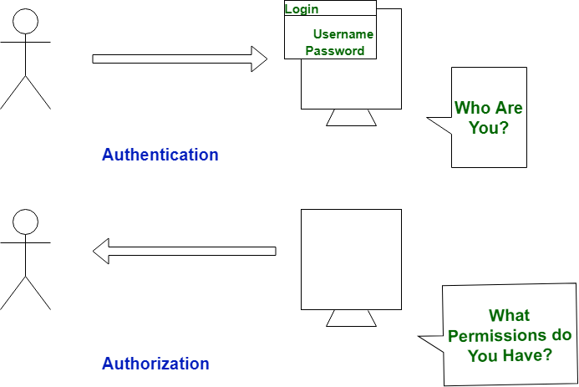

Authentication | Authorization
In authentication process, the identity of users are checked for providing the access to the system. | While in authorization process, person’s or user’s authorities are checked for accessing the resources.
In authentication process, users or persons are verified. | While in this process, users or persons are validated.
It is done before the authorization process. | While this process is done after the authentication process.
It needs usually user’s login details. | While it needs user’s privilege or security levels.
Authentication determines whether the person is user or not. | While it determines What permission do user have?
Authentication is the process of determining if the user is, who he claims to be. If the user enters his username as XYZ, then he should be able to prove that he is XYZ by providing the password known only to user XYZ. | Authorization is usually the next step after authentication wherein the system determines if the authenticated user is privileged to access the resource requested.

Spring MVC Application with Spring Security Example :
Security of a web-application revolves around three major concepts :
- Authentication
- Authorization
- Encryption

Steps 1: update the dependency in pom.xml
<dependency>
<groupId>org.springframework.security</groupId>
<artifactId>spring-security-core</artifactId>
<version>4.0.3.RELEASE</version>
</dependency>

<dependency>
<groupId>org.springframework.security</groupId>
<artifactId>spring-security-web</artifactId>
<version>4.0.3.RELEASE</version>
</dependency>

<dependency>
<groupId>org.springframework.security</groupId>
<artifactId>spring-security-config</artifactId>
<version>4.0.3.RELEASE</version>
</dependency>

We can now start with the actual Spring-Security implementation.

Let’s start with the gateway of the J2EE web-application, the WEB.xml. We need to declare the SpringSecurityFilterChain.
<web-app … >
<display-name>Servlet 3.0 Web Application</display-name>
<display-name>Spring Security Example</display-name>

<context-param>
<param-name>contextConfigLocation</param-name>
<param-value>
classpath:/security-config.xml
</param-value>
</context-param>

<filter>
<filter-name>springSecurityFilterChain</filter-name>
<filter-class>org.springframework.web.filter.DelegatingFilterProxy</filter-class>
</filter>

<filter-mapping>
<filter-name>springSecurityFilterChain</filter-name>
<url-pattern>/*</url-pattern>
</filter-mapping>

<listener>
<listener-class>org.springframework.web.context.ContextLoaderListener</listener-class>
</listener>

<servlet>
<servlet-name>Spring-Controller</servlet-name>
<servlet-class>org.springframework.web.servlet.DispatcherServlet</servlet-class>
<init-param>
<param-name>contextConfigLocation</param-name>
<param-value>classpath:/springWeb.xml</param-value>
</init-param>
<load-on-startup>1</load-on-startup>
</servlet>
<servlet-mapping>
<servlet-name>Spring-Controller</servlet-name>
<url-pattern>/</url-pattern>
</servlet-mapping>

<welcome-file-list>
<welcome-file>jsp/login.jsp</welcome-file>
</welcome-file-list>

</web-app>

Spring Security intercepts the incoming request via a Servlet filter – springSecurityFilterChain.
The DelegatingFilterProxy is a proxy for actual spring bean object which implements the javax.servlet.Filter interface. This filter guards the web-application from a host of malicious attacks like CSRF , Session Fixation, XSS etc.

We pass the location of spring security config file – security-config.xml to the filter via the contextConfigLocation web context parameter.

Let’s have a look at security-config.xml:
security-config.xml
<beans:beans >
<sec:http auto-config="true" use-expressions="true">
<sec:form-login login-page="/login"
login-processing-url="/authenticateUser" default-target-url="/welcome"
authentication-failure-url="/login" username-parameter="username"
password-parameter="password" />
<sec:access-denied-handler error-page="/403.jsp" />
<sec:intercept-url pattern="/login" access="permitAll" />
<sec:intercept-url pattern="/**" access="hasAuthority('AUTH_USER')" />
<sec:session-management invalid-session-url="/login" />
<sec:logout delete-cookies="JSESSIONID" logout-url="/logout" />
</sec:http>

<context:component-scan base-package="com.jcg.examples" />
<sec:authentication-manager>
<authentication-provider ref="customAuthenticationProvider" />
</sec:authentication-manager>
</beans:beans>

This is the file where we configure the actual security parameters for our application. The acts as a container for all HTTP-related security settings.

sec:form-login is the login form shown to the user when he tries to access any resource in the web-application. If we do not provide a login form, the spring provides its default login page with a username, password fields and submit button. The username-parameter and password-parameter are the names of the username and the password fields that the login page has. When these attributes are not explicitly provided they default to j_username and j_password. It is wise to rename to hide underlying technology. Spring extracts the username and password from the request using the names provided and provides them in the org.springframework.security.core.Authentication object.

The login-processing-url is the actual url which holds the resource to authenticate the user. We have defined a custom authenticator class and mapped it to /authenticateUser URL.

The developer may define multiple sec:intercept-url. This specifies the roles authorized to access the resource mapped by this filter-pattern. The user may also use hasRole expression to authenticate based in the user-roles, but in that case the role-name must start with ROLE_ or else the user is denied the access. The user may also choose to waive authentication process for certain resources from all security check like the login page, Javascript and CSS files. Not doing so may lead to infinite redirects to the same login page.

sec:logout tag is used to customize the logging-out process from the web-application.
The sec:authentication-manager is the actual bean that authenticates the user based on the username and password he enters in the login page. Here’s how the custom authenticator class looks like:

import org.springframework.security.authentication.AuthenticationCredentialsNotFoundException;
import org.springframework.security.authentication.AuthenticationProvider;
import org.springframework.security.authentication.UsernamePasswordAuthenticationToken;
import org.springframework.security.core.Authentication;
import org.springframework.security.core.AuthenticationException;
import org.springframework.security.core.GrantedAuthority;
import org.springframework.stereotype.Component;

@Component
public class CustomAuthenticationProvider implements AuthenticationProvider{
@Override
public Authentication authenticate(Authentication authentication) throws AuthenticationException {
String userName = authentication.getName();
String password = authentication.getCredentials().toString();

if (authorizedUser(userName, password)) {
List<GrantedAuthority> grantedAuths = new ArrayList<>();
grantedAuths.add(()-> {return "AUTH_USER";});
Authentication auth = new UsernamePasswordAuthenticationToken(userName, password, grantedAuths);
System.out.println(auth.getAuthorities());
return auth;
}
else {
throw new AuthenticationCredentialsNotFoundException("Invalid Credentials!");
}
}
private boolean authorizedUser(String userName, String password) {
System.out.println("username is :" + userName+" and password is "+password );
if("Chandan".equals(userName) && "Chandan".equals(password))
return true;
return false;
}

@Override
public boolean supports(Class<?> authentication) {
return UsernamePasswordAuthenticationToken.class.isAssignableFrom(authentication);
}
}

Our custom authenticator class implements the org.springframework.security.authentication.AuthenticationProvider interface. The interface provides us with simple method which will help simplify the process of user-authentication for us.

authenticate(Authentication authentication) : This method takes the authentication request object as a parameter. This object contains the username and password the user entered in the login page. Upon successful authentication the users roles are populated in a new org.springframework.security.authentication.UsernamePasswordAuthenticationToken authentication object. The resource requested by the user is then checked against the role in this authentication object. If the role matches the access rights for the user is allowed to access the resource. If not, the user is redirected to the error-page defined in the sec:access-denied-handler tag.

In this example we have implemented the org.springframework.security.core.GrantedAuthority interface using the lambda expression and provided the user with the AUTH_USER role.

Once the user is successfully authenticated and authorized, the url is directed to DispatcherServlet configured in the web.xml. The DispatcherServlet in turn invokes the Controller method mapped to the resource’s url.
Here’s a simple above configuration xml for the initialization of the controllers. Remember to pass this xml file-name in the init-param of the DispatcherServlet in web.xml.

Spring Boot + Security Hello world Example : we configure a spring boot application to add basic authorization and authentication.

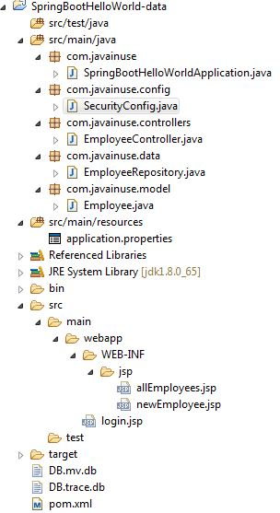

In the Maven we only need the spring-boot-starter-security dependency.
<dependency>
<groupId>org.springframework.boot</groupId>
<artifactId>spring-boot-starter-security</artifactId>
<scope>test</scope>
</dependency>

Lets not add any security configuration and run this code.
Goto-http://localhost:8080/listEmployees.html , you will get login page username & password

We can see that no security configuration is added still it asks for username password. This is expected behaviour. We will see that the password is system generated when we run the boot application.

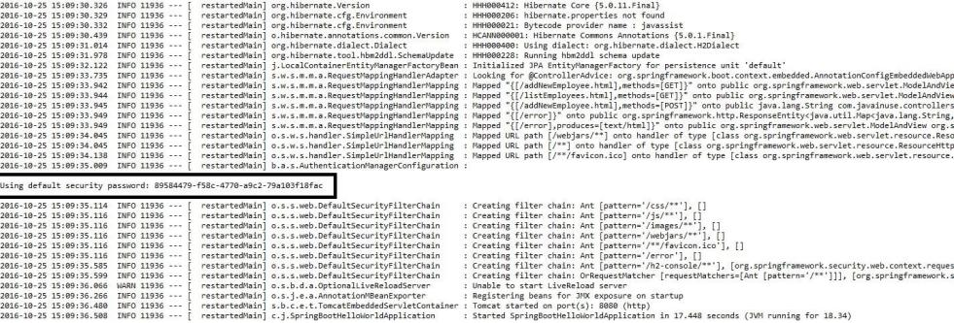

Thus by just adding the spring boot security starter dependency the basic security has already been configured by default.

Lets customize the security configuration by writing our own authorization and authentication. For this create a new class SecurityConfig that extends the WebSecurityConfigurerAdapter and overrides its methods.

import org.springframework.context.annotation.Configuration;
import org.springframework.security.config.annotation.authentication.builders.AuthenticationManagerBuilder;
import org.springframework.security.config.annotation.web.builders.HttpSecurity;
import org.springframework.security.config.annotation.web.configuration.EnableWebSecurity;
import org.springframework.security.config.annotation.web.configuration.WebSecurityConfigurerAdapter;

@Configuration
@EnableWebSecurity
public class SecurityConfig extends WebSecurityConfigurerAdapter {

@Override
public void configure(AuthenticationManagerBuilder auth) throws Exception {
auth.inMemoryAuthentication().withUser("javainuse")
.password("javainuse").roles("USER");
}

@Override
public void configure(HttpSecurity http) throws Exception {
http.antMatcher("/**").authorizeRequests().anyRequest().hasRole("USER")
.and().formLogin().loginPage("/login.jsp")
.failureUrl("/login.jsp?error=1").loginProcessingUrl("/login")
.permitAll().and().logout()
.logoutSuccessUrl("/listEmployees.html");

}

}

Understand Spring Security Architecture and implement Spring Boot Security :
how Spring Security works and its architecture. We will be creating a Spring Boot Project to expose two REST API's
/helloadmin
/hellouser

We will be implementing Spring Security such that a client having Admin role will be able to access both /helloadmin and /hellouser API.
While a client having User role will be able to access only /hellouser API

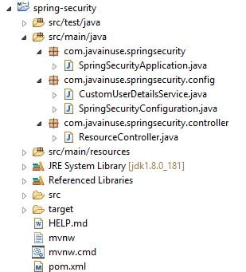

pom.xml: Add the dependency in pom.xml

Next create the Controller class to expose the REST API's -

@RestController
public class ResourceController {

@RequestMapping({"/hellouser"})
public String helloUser(){
return "Hello User";
}
@RequestMapping({"/helloadmin"})
public String helloAdmin(){
return "Hello Admin";
}
}

Configure Spring Security for Spring Boot Project :
Understanding Spring Security Architecture : Let us understand how Spring Security Works.
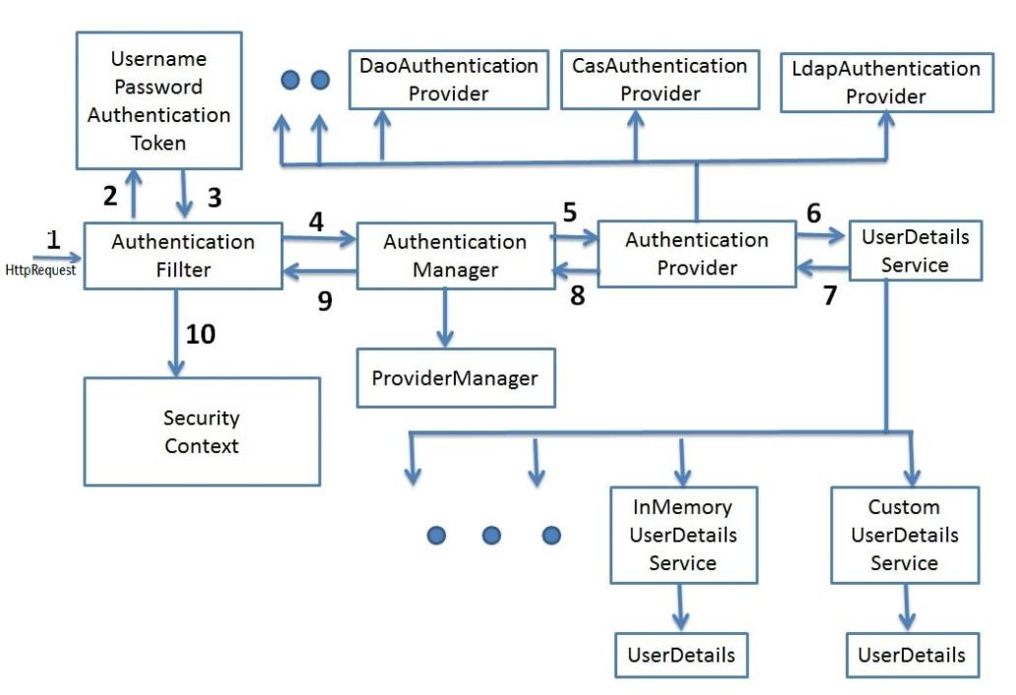

Filters - Before the request reaches the Dispatcher Servlet, it is first intercepted by a chain of filters.

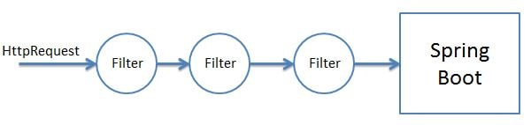
These filters are responsible for Spring Security. So any incoming request will go through these filters and it is here that authentication and authorization takes place. Based on the type of requests there are different Authentication Filters like the BasicAuthenticationFilter,UsernamePasswordAuthenticationFilter etc.

Authentication Object Creation - When the request is intercepted by the appropriate AuthenticationFilter it retrieves the username and password from the request and creates the Authentication Object. If the extracted credentials are username and password, then UsernamePasswordAuthenticationToken is created.

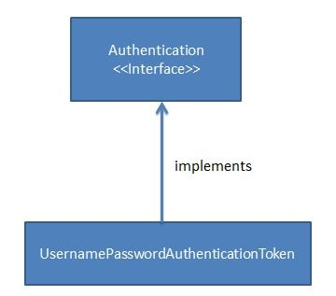
AuthenicationManager - Using the Authentication Object created the filter will then call the authenticate method of the Authentication Manager. The Authentication Manager is only a interface and actual implementation of the authenticate method is provided by the ProviderManager.
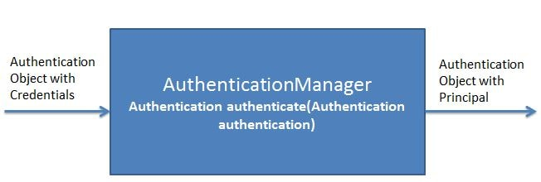

Important point to note here is that the Authentication Manager takes an Authentication object as input and after successful authentication again returns an object of type Authentication.
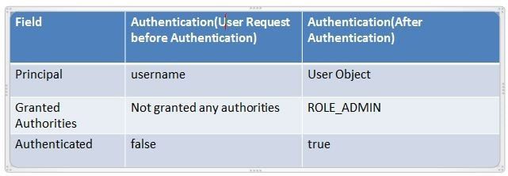

The ProviderManager has a list of AuthenticationProviders. From it's authenticate method it calls the authenticate method of the appropriate AuthenticateProvider. In response it gets the Principal Authentication Object if the authentication is successful.

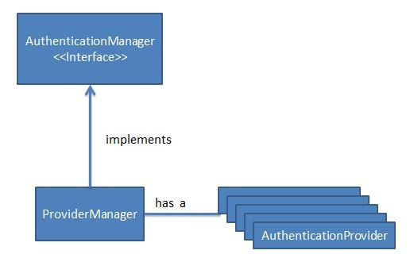

AuthenticationProvider - The AuthenicationProvider is an interface with a single authenticate method.
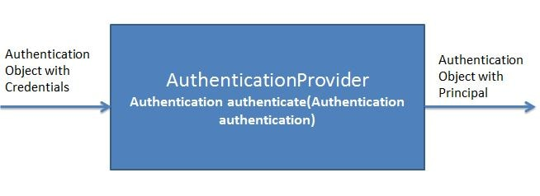
It has various implementations like CasAuthenticationProvider,DaoAuthenticationProvider. Depending on the implementation an appropriate AuthenicationProvider implementation is used. It is in the AuthenticationProvider Implementation authenticate method where all the actual authentication takes place.

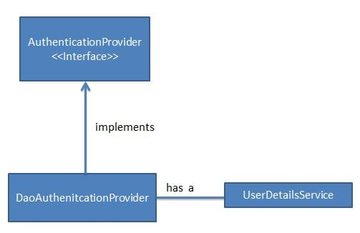
Using the UserDetails service the AuthenticationProvider fetches the User Object corresponding to the username. It fetches this User Object from either a database, internal memory or other sources. This User object credentials are then compared with the incoming Authentication Object credentials. If Authentication is successful then the Principal Authentication Object is returned in response.

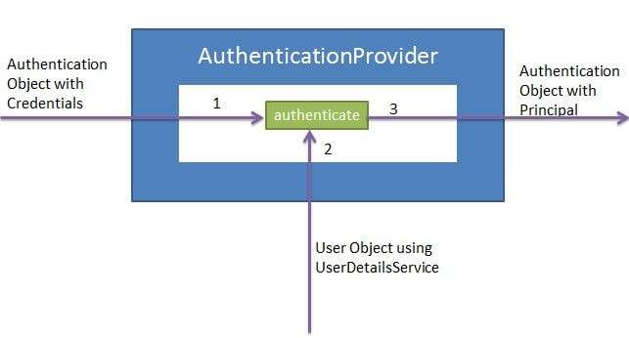
UserDetailsService - The UserDetailsService is an interface having a single method named loadUserByUsername.
It has various implementations CachingUserDetailsService, JDBCDaoImpl etc. Based on the implementation an appropriate UserDetailsService is called.

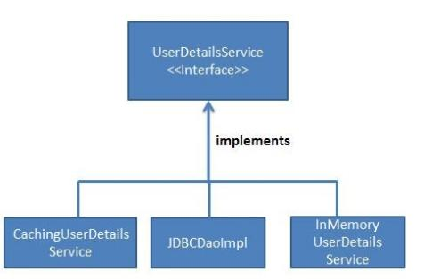

It is responsible for fetching the User Object with username and password against which the incoming User Object will be compared.

Add Spring Security to Spring Boot :
We will need to add the Spring Security Starter dependency in the pom.xml

<dependency>
<groupId>org.springframework.boot</groupId>
<artifactId>spring-boot-starter-security</artifactId>
</dependency>

As soon as we add the spring security dependency to the project the basic authentication gets activated by default. If we now start the application, Basic Security is enabled by default by Spring security due to the spring auto configurations.
In the console we get the password while the username is user-

We will now be creating our own custom Spring Security Configuration by extending the WebSecurityConfigurerAdapter In this class we will be making use of the PasswordEncoder. In

@Configuration
@EnableWebSecurity
public class SpringSecurityConfiguration extends WebSecurityConfigurerAdapter{
@Autowired
CustomUserDetailsService userDetailsService;

@Bean
public PasswordEncoder passwordEncoder() {
return new BCryptPasswordEncoder();
}
@Override
public void configure(AuthenticationManagerBuilder auth) throws Exception {
auth.userDetailsService(userDetailsService).passwordEncoder(passwordEncoder());
}
@Override
protected void configure(HttpSecurity httpSecurity) throws Exception {
// We don't need CSRF for this example
httpSecurity.csrf().disable()
.authorizeRequests().antMatchers("/helloadmin")
.hasRole("ADMIN")
.antMatchers("/hellouser")
.hasAnyRole("ADMIN","USER")
.and().httpBasic();
}
}

Create a custom UserDetails Service class-

@Service
public class CustomUserDetailsService implements UserDetailsService {

@Override
public UserDetails loadUserByUsername(String username) throws UsernameNotFoundException {
List<SimpleGrantedAuthority> roles=null;
if(username.equals("admin")) {
roles = Arrays.asList(new SimpleGrantedAuthority("ROLE_ADMIN"));
return new User("admin", "$2y$12$I0Di/vfUL6nqwVbrvItFVOXA1L9OW9kLwe.1qDPhFzIJBpWl76PAe",
roles);
}
else if(username.equals("user")) {
roles = Arrays.asList(new SimpleGrantedAuthority("ROLE_USER"));
return new User("user", "$2y$12$VfZTUu/Yl5v7dAmfuxWU8uRfBKExHBWT1Iqi.s33727NoxHrbZ/h2",
roles);
}
throw new UsernameNotFoundException("User not found with username: " + username);
}
}
Spring Boot Form Security Login Example :It used http basic security. Besides being not visually helpful it also has some other drawbacks like once logged in, then to log out user has to close the browser.
In this example we make use of the login form provided by Spring Security for authenticating users.

Next we configure the Spring Security. In the configuration we specify which urls are to be intercepted, and are to be accessed by which users and having which roles. Next we create users along with passwords and specify them a role.
We will be creating two logins
Username | Role | Pages Accessible | Pages not Accessible
javainuse | USER  ADMIN | Welcome page  Show All Employees Page  Add Employee | None
employee | USER | Welcome page  Show All Employees Page | Add Employee

@Configuration
@EnableWebSecurity
public class EmployeeSecurityConfiguration extends WebSecurityConfigurerAdapter {

@Override
public void configure(WebSecurity web) throws Exception {
web.ignoring().antMatchers("/resources/**");
}

@Override
protected void configure(HttpSecurity http) throws Exception {
http.authorizeRequests().antMatchers("/").permitAll().antMatchers("/welcome")
.hasAnyRole("USER", "ADMIN").antMatchers("/getEmployees").hasAnyRole("USER", "ADMIN")
.antMatchers("/addNewEmployee").hasAnyRole("ADMIN").anyRequest().authenticated().and().formLogin()
.permitAll().and().logout().permitAll();

http.csrf().disable();
}

@Autowired
public void configureGlobal(AuthenticationManagerBuilder authenticationMgr) throws Exception {
authenticationMgr.inMemoryAuthentication().withUser("employee").password("employee")
.authorities("ROLE_USER").and().withUser("javainuse").password("javainuse")
.authorities("ROLE_USER", "ROLE_ADMIN");
}
}

The annotation @EnableWebSecurity enables Web security; otherwise, it remains disabled by default. Now, to configure the security, we can either implements the interface called WebSecurityConfigurer or extend the more convenient class called WebSecurityConfigurerAdapter. The advantage of extending the adapter class is that we can configure Web security by overriding only those parts that we are interested in; others can remain their default form. There are three variations of the configure method that we can override to configure and secure the application:
- void configure( AuthenticationManagerBuilder auth): To configure user details services
- void configure( HttpSecurity http): To configure how requests are secured by interceptors
- void configure( WebSecurity web): To configure Spring Security's filter chain

The default filter chain is fine for most needs. So, we may configure the other two in the following manner.

public class SecurityConfiguration extends
WebSecurityConfigurerAdapter {

@Autowired
private CustomUserDetailsService userDetailsService;
@Override
protected void configure(AuthenticationManagerBuilder auth)
throws Exception {
auth.userDetailsService(userDetailsService)
.passwordEncoder(getPasswordEncoder());
}

private PasswordEncoder getPasswordEncoder() {
return new PasswordEncoder() {
@Override
matches(CharSequence rawPassword, String
encodedPassword) {
// Verifies whether encoded password obtained matches
// with the rawPassword CharSequence
}
@Override
public String encode(CharSequence rawPassword) {
// Code for password encoding
}
};
}

// ...
}
The PasswordEncoder is a service interface provided by the Spring Security framework for encoding passwords.

The interceptor's secure method configuration may look like this:

public class SecurityConfiguration extends WebSecurityConfigurerAdapter {

@Override
protected void configure(HttpSecurity http) throws
Exception {
http.authorizeRequests()
.antRequest().authenticated()
.and().formLogin().and().httpBasic();
}

// ...
}
This simple configuration specifies how HTTP requests are secured. The chain of method enforces that all HTTP requests are authenticated via a login form. The form-based login is a predefined login page provided by Spring Security.

When overriding the configure(AuthenticationManagerBuilder auth) method, we can use in-memory user storage as follows:

public class SecurityConfiguration extends
WebSecurityConfigurerAdapter {
@Override
protected void configure(AuthenticationManagerBuilder auth)
throws Exception {
auth.inMemoryAuthentication()
.withUser("user").password("password").roles("USER").and()
.withUser("admin").password("password").roles("USER",
"ADMIN");
}
// ...
}

Spring Boot Security - Introduction to OAuth2 : OAuth (Open Authorization) is a simple way to publish and interact with protected data.
It is an open standard for token-based authentication and authorization on the Internet. It allows an end user's account information to be used by third-party services, such as Facebook, without exposing the user's password.
The OAuth specification describes five grants for acquiring an access token:
- Authorization code grant
- Implicit grant
- Resource owner credentials grant
- Client credentials grant
- Refresh token grant
What actually is OAuth? : Consider the use case of Quora. Go to Quora.com.
If you are a new user you need to signup. You can signup using google or facebook account. When doing so you are authorizing Google or Facebook to allow quora to access you profile info with Quora. This authorizing is done using OAuth. Here you have in no way shared your credentials with Quora.

In the above example of Quora, we have 3 actors-
Resource Owner - This is the user who wants to sign up using Quora.
Client Application - This will be Quora
Resource Server - This will be Gmail or Facebook.
Authorization Server - The resource server hosts the protected user accounts, and the authorization server verifies the identity of the user then issues access tokens to the application.

we will be implementing our own client application and resource server.
The resource owner will then using OAuth authorize the resource server to share data with the client application.
The client application must first register with the authorization server associated with the resource server. This is usually a one-time task. Once registered, the registration remains valid, unless the client application registration is revoked. At registration the client application is assigned a client ID and a client secret (password) by the authorization server. The client ID and secret is unique to the client application on that authorization server.
For example if we click on Continue with Google, we get the following screen. Here we can see Quora client id.
Quora got this client id and a secret key when it registered with Google.
The actual authorization process that takes place between Quora and Google using OAuth is as follows-

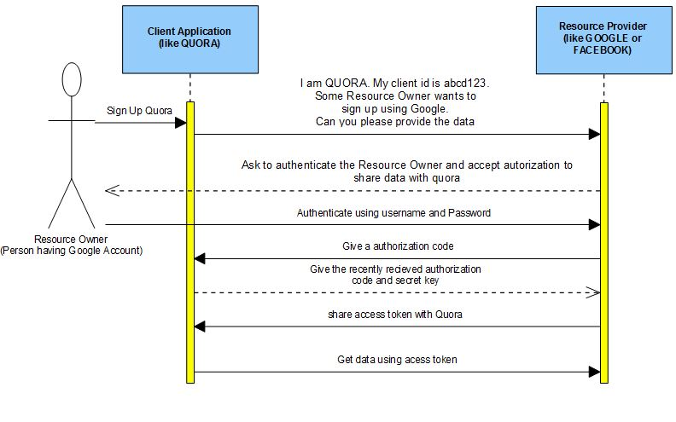
Similar to the above flow we will be developing our own client application and Resource Server. Using OAuth the Resource server will then share the data with the client application. Also we will be assuming that the client is already registered with the Resource Server and has been assigned a unique client id and secret key.
- Spring Boot Client Application - We already have a unique client id -'javainuse' and secret key - 'secret'. We need to import data from Resource Server.
- Resource Server - Using OAuth we configure authorization server. It already has the unique key configured for recognizing our client application.
https://www.javainuse.com/spring/spring-boot-oauth-authorization-code
https://www.javainuse.com/spring/spring-boot-oauth-access-token
https://www.marcobehler.com/guides/spring-security

Spring Boot Security Auto-Configuration : In this article, we'll have a look at Spring Boot's opinionated approach to security.
Simply put, we're going to focus on the default security configuration and how we can disable or customize it if we need to.

- Default Security Setup : In order to add security to our Spring Boot application, we need to add the security starter dependency:
<dependency>
<groupId>org.springframework.boot</groupId>
<artifactId>spring-boot-starter-security</artifactId>
</dependency>

This will include the SecurityAutoConfiguration class – containing the initial/default security configuration.
by default, the Authentication gets enabled for the Application.

There are some predefined properties, such as:
spring.security.user.name
spring.security.user.password

If we don't configure the password using the predefined property spring.security.user.password and start the application, we'll notice that a default password is randomly generated and printed in the console log:
Using default security password: c8be15de-4488-4490-9dc6-fab3f91435c6

- Disabling the Auto-Configuration : To discard the security auto-configuration and add our own configuration, we need to exclude the SecurityAutoConfiguration class.

@SpringBootApplication(exclude = { SecurityAutoConfiguration.class })

Or by adding some configuration into the application.properties file:
spring.autoconfigure.exclude=org.springframework.boot.autoconfigure.security.SecurityAutoConfiguration

NOTE : There are also some particular cases in which this setup isn't quite enough.
For example, almost each Spring Boot application is started with Actuator in the classpath. This causes problems because another auto-configuration class needs the one we've just excluded, so the application will fail to start.
In order to fix this issue, we need to exclude that class; and, specific to the Actuator situation, we need to exclude ManagementWebSecurityAutoConfiguration.

Disabling vs. Surpassing Security Auto-Configuration :
There's a significant difference between disabling autoconfiguration and surpassing it.
By disabling it, it's just like adding the Spring Security dependency and the whole setup from scratch. This can be useful in several cases:
- Integrating application security with a custom security provider
- Migrating a legacy Spring application with already existing security setup – to Spring Boot
But, most of the time we won't need to fully disable the security auto-configuration.
The way Spring Boot is configured permits surpassing the autoconfigured security by adding in our new/custom configuration classes. This is typically easier, as we're just customizing an existing security setup to fulfill our needs.

Configuring Spring Boot Security : If we've chosen the path of disabling security auto-configuration, we naturally need to provide our own configuration.
As we've discussed before, this is the default security configuration; we can customize it by modifying the property file.
We can, for example, override the default password by adding our own:
spring.security.user.password=password
If we want a more flexible configuration, with multiple users and roles for example – we need to make use of a full @Configuration class:

@Configuration
@EnableWebSecurity
public class BasicConfiguration extends WebSecurityConfigurerAdapter {

@Override
protected void configure(AuthenticationManagerBuilder auth) throws Exception {
PasswordEncoder encoder =
PasswordEncoderFactories.createDelegatingPasswordEncoder();
auth
.inMemoryAuthentication()
.withUser("user")
.password(encoder.encode("password"))
.roles("USER")
.and()
.withUser("admin")
.password(encoder.encode("admin"))
.roles("USER", "ADMIN");
}

@Override
protected void configure(HttpSecurity http) throws Exception {
http
.authorizeRequests()
.anyRequest()
.authenticated()
.and()
.httpBasic();
}
}
The @EnableWebSecurity annotation is crucial if we disable the default security configuration.
If missing, the application will fail to start. The annotation is only optional if we're just overriding the default behavior using a WebSecurityConfigurerAdapter.
Also, notice that we need to use the PasswordEncoder to set the passwords when using Spring Boot 2.

- Spring Boot 2 Security vs Spring Boot 1 Security
- In Spring Boot 2, if we want our own security configuration, we can simply add a custom WebSecurityConfigurerAdapter. This will disable the default auto-configuration and enable our custom security configuration.
- Spring Boot 2 uses most of Spring Security’s defaults. Because of this, some of the endpoints that were unsecured by default in Spring Boot 1 are now secured by default.

These endpoints include static resources such as /css/**, /js/**, /images/**, /webjars/**, /**/favicon.ico, and the error endpoint. If we need to allow unauthenticated access to these endpoints, we can explicitly configure that.

Spring Boot 2 has removed the following Spring Boot 1 properties:
security.basic.authorize-mode
security.basic.enabled
security.basic.path
security.basic.realm
security.enable-csrf
security.headers.cache
security.headers.content-security-policy
security.headers.content-security-policy-mode
security.headers.content-type
security.headers.frame
security.headers.hsts
security.headers.xss
security.ignored
security.require-ssl
security.sessions

Secure a Spring Boot App With Spring Security and PreAuthorize :
The first way focuses on overriding the original setting on the HttpSecurity object by building WebSecurityConfigurerAdapter and using the fluent API. The second method, which is also the main focus of this tutorial, is to use method-level security — also known as the @PreAuthorize annotation on controller method.

HttpSecurity method is universal and is applied to all requests. The pattern matching for endpoints and fluent API exposed by HttpSecurity is great for building universal authentication policies. This is also where implementation options, such as OAuth 2.0, Form Login, and HTTP Basic are exposed.

Method-level security is implemented by placing the @PreAuthorize annotation on controller methods (actually one of a set of annotations available, but the most commonly used). This annotation contains a Spring Expression Language (SpEL) snippet that is assessed to determine if the request should be authenticated.

If access is not granted, the method is not executed, and an HTTP Unauthorized is returned. In practice, using the @PreAuthorize annotation on a controller method is very similar to using HttpSecurity pattern matchers on a specific endpoint.

Differentiate Between Spring Security’s @PreAuthorize and HttpSecurity :
- The HttpSecurity method rejects the request earlier, in a web request filter, before controller mapping has occurred. directly before the execution of the controller method. This means that configuration in HttpSecurity is applied before @PreAuthorize.
- Second, HttpSecurity is tied to URL endpoints, while @PreAuthorize is tied to controller methods and is actually located within the code adjacent to the controller definitions.
- Another advantage that @PreAuthorize presents over HttpSecurity is the use of SpEL. Spring Expression Language allows you to make authorization decisions based on complex expressions that can access built-in authentication objects (such as authentication and principal), dependency-injected method parameters, and query parameters.

This controller defines two endpoints: / and /restricted. You will be adding method-level security to the /restricted endpoint in a bit.

protected void configure(HttpSecurity http) throws Exception {
...
http
.authorizeRequests()
.anyRequest().authenticated()
.and()
.formLogin().and()
.httpBasic();
}
By default, all requests require authentication. Form-based authentication and HTTP Basic auth are enabled for all requests.

Enable Method-level Security for Spring @PreAuthorize :

@PreAuthorize("isAuthenticated()")
@RequestMapping("/restricted")
@ResponseBody
public String restricted() {
return "You found the secret lair!";
}

This time you will be able to navigate to the home page but going to the /restricted endpoint gives you an (admittedly ugly) whitelabel error page.
@Controller
@PreAuthorize("isAuthenticated()")
public class WebController {

@PreAuthorize("permitAll()")
@RequestMapping("/")
@ResponseBody
public String home() {
return "Welcome home!";
}

@RequestMapping("/restricted")
@ResponseBody
public String restricted() {
return "You found the secret lair!";
}
}

you’ve used the @PreAuthorize annotation to restrict the entire controller class to authenticated users and to explicitly allow all requests (regardless of authentication status) to the home endpoint.
I know we’ve been calling it “method-level” security, but, in fact, these @PreAuthorize annotation can also be added to controller classes to set a default for the entire class. This is also where the @PreAuthorize("permitAll()") comes in handy because it can override the class-level annotation.
o implement this, change the WebController class to this (removing all the @PreAuthorize annotations):

@Controller
public class WebController {
@RequestMapping("/")
@ResponseBody
public String home() {
return "Welcome home!";
}
@RequestMapping("/restricted")
@ResponseBody
public String restricted() {
return "You found the secret lair!";
}
}

And change the WebSecurity class to this:

@Configuration
@EnableGlobalMethodSecurity(prePostEnabled = true)
public class SecurityConfig extends WebSecurityConfigurerAdapter {
protected void configure(final HttpSecurity http) throws Exception {
http.antMatcher("/**")
.authorizeRequests()
.antMatchers("/").permitAll()
.anyRequest().authenticated()
.and().formLogin();
}
}
What you’ve done is use SecurityConfig class to explicitly permit all requests on the home endpoint while requiring authentication on all other endpoints. This sets a blanket minimum authentication requirement for your app. You also re-enabled form-based authentication.

What is JWT? : JWT stands for JSON Web Token. JSON Web Token (JWT) is an open standard.
This information can be verified and trusted because it is digitally signed. The client will need to authenticate with the server using the credentials only once. During this time the server validates the credentials and returns the client a JSON Web Token(JWT). For all future requests the client can authenticate itself to the server using this JSON Web Token(JWT) and so does not need to send the credentials like username and password.

Workflow of how JWT is used :
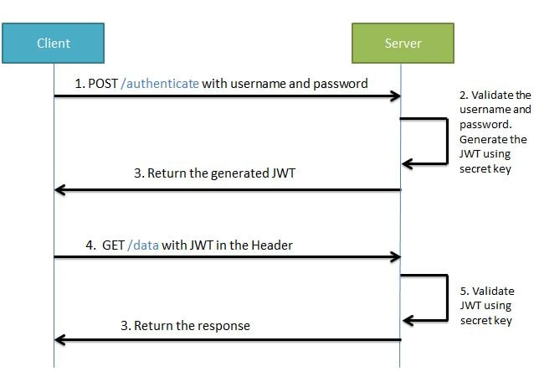

During the first request the client sends a POST request with username and password.then successful authentication the server generates the JWT and sends this JWT to the client. This JWT can contain a payload of data.

On all subsequent requests the client sends this JWT token in the header. Using this token the server authenticates the user.
So we don't need the client to send the user name and password to the server during each request for authentication, but only once.

Structure of JWT :
JWT has the following format -header.payload.signature.

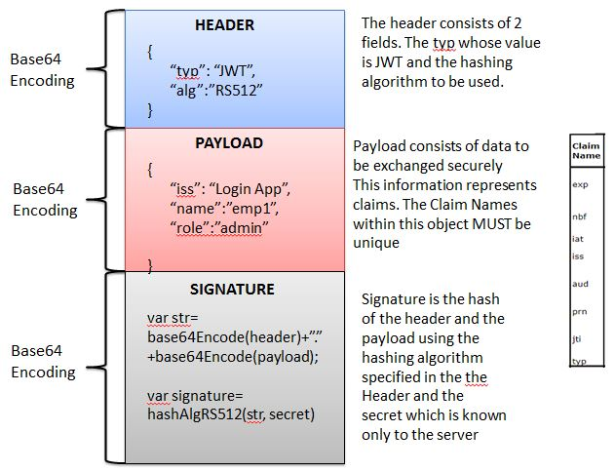

An important point to remember about JWT is that the information in the payload of the JWT is visible to everyone. So we should not pass any sensitive information like passwords in the payload. We can encrypt the payload data if we want to make it more secure.

Spring Security and JWT Configuration
We will be configuring Spring Security and JWT for performing 2 operations-
Generating JWT - Expose a POST API with mapping /authenticate. On passing correct username and password it will generate a JSON Web Token(JWT)
Validating JWT - If user tries to access GET API with mapping /hello. It will allow access only if request has a valid JSON Web Token(JWT).

Generating JWT -
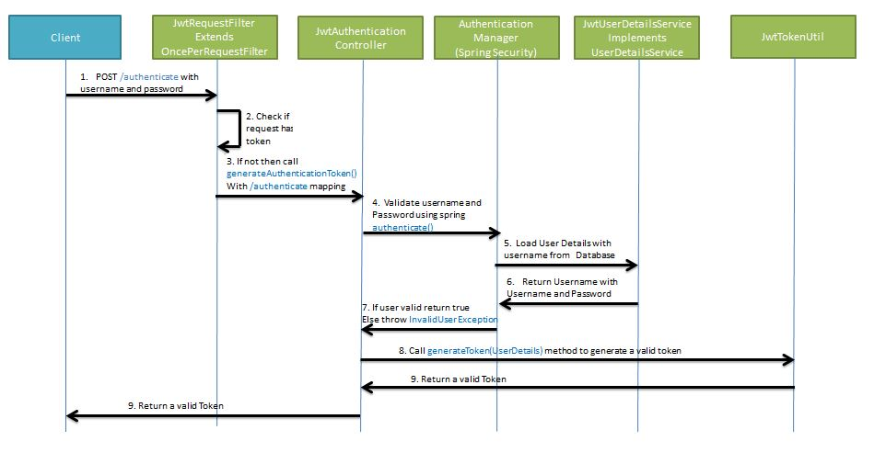
- POST /authenticate with username and password - Client
- Check request has token then return it to client.
- If not then call generateAuthenticationToken() with /authenticate mapping - JwtRequestFilter Extends OncePerrequestFilet
- Validate username and password spring authenticate() :AuthenticationManager(SpringSecurity)
- Load user details with username from data source
- Return username with username and password - jwtUserdetailsservice class extends Userdetailsservice in spring
- If User valid return true else throw InvalidUserException
- Call generateToken(UserDetails) method to generate a valid token
- Return a valid token to client

Validating JWT :

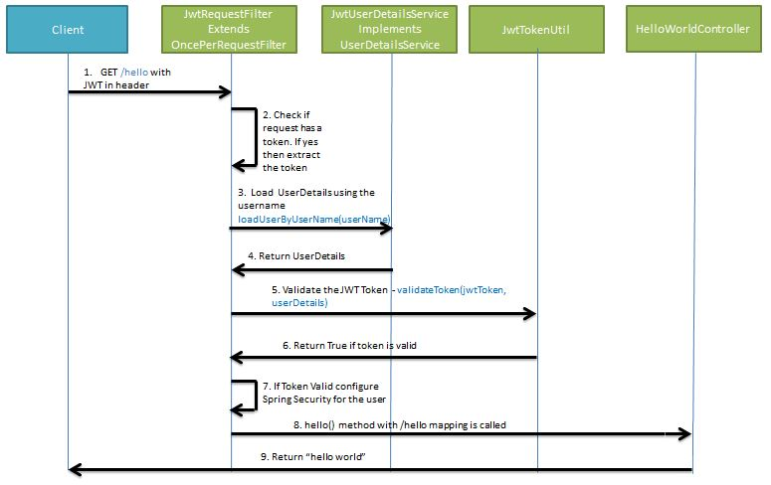

- GET /hello with JWT in header
- Check if request has a token . if yes then extract the token.
- Load userDetails using the username loadUserByUserName(username)
- Return UserDetails
- Validate the JWT Token - validateTOken(jwtToken ,userDetails)
- Return the JWT Token is valid
- If Token valid configure Spring Security for the user
- Hello() method with /hello mapping is called
- Return “hello world”

